

Report for Car rentals and reservation system

CSE 326



LOVELY PROFESSIONAL UNIVERSITY

PHAGWARA,PUNJAB

NAME : ISHITA MISHRA

REGISTRATION NUMBER : 12306247

SECTION : K23HK

ROLL NUMBER : 29

PROGRAM : B .Tech in COMPUTER SCIENCE AND ENGNEERING

SUBMITTED TO : Miss. Sheetal Chauhan

SCHOOL : School of Computer Science and Engineering

NAME OF UNIVERSITY : LOVELY PROFESSIONAL UNIVERSITY

S.No. TABLE OF CONTENT PAGE No.

1. INTRODUCTION 4

2. TECHNOLOGY USED 5

3. WORKFLOW 6-7

4. SNIPPETS OF PROPERTIES 8

5. CODE OF HTML 9-18

6. CODE OF CSS 19-35

7. CODE OF JAVA SCRIPT 36

8. SCREENSHOTS OF WEBPAGES 37-39

9. REFERENCES 40

***Abstract:-***

The Car Rental and Reservation System is a comprehensive software solution designed to streamline and optimize the process of renting and reserving vehicles. This system aims to provide users with a user-friendly platform to browse available cars, make reservations, manage bookings, and handle administrative tasks efficiently.

Key features include a user-friendly interface for customers to search, compare, and select vehicles based on their preferences, such as model, price range, and availability.

***Acknowledgement:-***

We would like to express our heartfelt gratitude to Miss. Sheetal Chauhan for giving us the opportunity to work under her guidance and help us gain immensely enriching professional experience. Our sincere thanks to project in charge and our internal project guide for giving us valuable inputs and ideas right from the selection of topic for project until its successful completion.

Many thanks to my friends and parents as well, who spent countless hours to listen and provide feedbacks.

***INTRODUCTION***

Welcome to our Car Rental and Reservation System, a user-friendly and efficient online platform designed to simplify and enhance your car rental experience. Whether you're planning a business trip, a weekend getaway, or simply need a reliable mode of transportation, our website is here to provide you with a seamless and convenient solution. In today's fast-paced world, the demand for convenient and flexible transportation solutions is on the rise. The Car Rental and Reservation System Website project aims to address this need by providing a user-friendly platform for individuals and businesses to easily rent and reserve vehicles online. This innovative system brings efficiency and simplicity to the car rental process, offering a seamless experience for both customers and rental service providers.

Objective:

Our primary objective is to offer a hassle-free and transparent car rental service, allowing users to easily browse, select, and reserve vehicles of their choice. With a user-centric approach, we aim to provide a secure and efficient platform that meets the diverse needs of our customers.

Our Car Rental and Reservation System is designed with your convenience in mind, aiming to redefine the way you approach car rentals. Experience a seamless, user-friendly interface that makes the entire process—from browsing to reservation—effortless and enjoyable. Thank you for choosing our platform, and we look forward to providing you with an exceptional car rental experience.

***Technology Used:-***

In the development of this website, we have used three languages.

They are:

• HTML: HTML (Hypertext Markup Language) is the most basic building block of the Web. It defines the meaning and structure of web content. "Hypertext" refers to links that connect web pages to one another, either within a single website or between websites

• CSS: Cascading Style Sheets, fondly referred to as CSS, is a simple design language intended to simplify the process of making web pages presentable. CSS handles the look and feel part of a web page. Using CSS, you can control the colour of the text, the style of fonts, the spacing between paragraphs, how columns are sized and laid out, what background images or colours are used, layout designs, variations in display for different devices and screen sizes as well as a variety of other effects.

• JavaScript: JavaScript is a scripting or programming language that allows you to implement complex features on web pages.

***Workflow:-***

1**. User Registration**:

- Customers start by creating an account on the car rental website. They provide personal information, contact details, and may need to upload necessary documents (driver's license, identification, etc.).

2. **Browsing and Searching**:

- Users can browse the available cars on the website. They can filter cars based on criteria such as location, car type, rental duration, and price.

3. **Car Selection**:

- Once users find a suitable car, they can view details such as model, features, rental rates, and availability.

4**. Reservation**:

- Users initiate a reservation by selecting the desired rental period and providing any additional information required. The system checks for availability during the specified timeframe.

5. **Price Calculation**:

- The system calculates the total cost based on the selected car, rental duration, and any additional services (insurance, fuel options, etc.). This information is presented to the user.

6. **Payment Processing**:

- Users provide payment details, and the system processes the payment securely. The website should support various payment methods.

7. **Confirmation**:

- Once the payment is successful, the system generates a confirmation receipt and sends it to the user via email. The reservation details are also stored in the system's database.

8. **Pick-up and Return**:

- Users pick up the reserved car at the designated location at the scheduled time. The rental system records the start of the rental period. At the end of the rental period, users return the car.

9**. Feedback and Ratings**:

- After the rental period, users may have the option to provide feedback and ratings for the rental experience.

***Snippets Of Properties***

When building a website using CSS (Cascading Style Sheets), we have used various properties to control the visual presentation and layout of our web pages.

Color and Background, Fonts and Text Styling, Margins and Padding, Layout, Border and Border-radius, Positioning, Flexbox, Transition and Animation, Media Queries for Responsive Design, Box Shadow.

HTML (Hypertext Markup Language) is the standard markup language used to create the structure of web pages. Here are some essential HTML properties we have used:

<html>, <head>, <title>

<meta charset="utf-8">: Declares the character encoding.

<h1>, <h2>, ... <h6>, <p> , <strong> or <b>, <em> or <i>, <a href="URL">: Defines a hyperlink.

<img src="image.jpg" alt="Description">: Embeds an image.

<div></div> <section></section>

**HTML CODE :**

<!DOCTYPE html>

<html lang="en">

<head>

<meta charset="UTF-8">

<meta name="viewport" content="width=device-width, initial-scale=1.0">

<title>Car Rental Website</title>

<link rel="stylesheet" href="style.css">

<link rel="stylesheet"

href="https://cdn.jsdelivr.net/npm/boxicons@latest/css/boxicons.min.css">

</head>

<body>

<header>

<a href="#" class="logo"><img src="img/jeep.png" alt=""></a>

<div class="bx bx-menu" id="menu-icon"></div>

<ul class="navbar">

<li><a href="#home">Home</a></li>

<li><a href="#ride">Ride</a></li>

<li><a href="#services">Services</a></li>

<li><a href="#reviews">About</a></li>

<li><a href="#reviews">Reviews</a></li>

</ul>

<div class="header-btn">

<a href="#" class="sign-up">Sign Up</a>

<a href="#" class="sign-in">Sign In</a>

</div>

</header>

<section class="home" id="home">

<div class="text">

<h1><span>RIDEX</span> <br>Car Rental Made Easy</h1>

<p>Save money on rental cars by searching for car hire deals on Ridex<br>Find the right car hire for wherever your trip takes you.</p>

<div class="app-stores">

<img src="img/ios.png" alt="">

<img src="img/play.png " alt="">

</div>

</div>

<div class="form-container">

<form action="">

<div class="input-box">

<span>Location</span>

<input type="search" name="" id="" placeholder="Search Places">

</div>

<div class="input-box">

<span>Pick-Up Date</span>

<input type="date" name="" id="">

</div>

<div class="input-box">

<span>Return Date</span>

<input type="date" name="" id="">

</div>

<input type="submit" name="" id="" class="btn">

</form>

</div>

</section>

<section class="ride" id="ride">

<div class="heading">

<span>How Its Work</span>

<h1>Rent with 3 Easy Steps</h1>

</div>

<div class="ride-container">

<div class="box">

<i class='bx bxs-map'></i>

<h2>Choose A Location</h2>

<p>Specify the city or airport where you want to pick up the rental car.</p>

</div>

<div class="box">

<i class='bx bxs-calendar-check'></i>

<h2>Pick-Up Date</h2>

<p>Indicate the date and time you plan to pick up the car. This helps the rental agency ensure the availability of the vehicle.</p>

</div>

<div class="box">

<i class='bx bxs-calendar-star'></i>

<h2>Book a car</h2>

<p>Provide your complete legal name including your phone number and email address and input your driver's license number, issue date, and expiration date.</p>

</div>

</div>

</section>

<section class="services" id="services">

<div class="heading">

<span>Best Services</span>

<h1>Explore Out Top Deals <br> From Top Rated Dealers</h1>

</div>

<div class="services-container">

<div class="box">

<div class="box-img">

<img src="img/car1.jpeg" alt="">

</div>

<p></p>

<h3>TATA Nexon</h3>

<h2> ₹2,598

<span>/day</span></h2>

<a href="#" class="btn">Rent Now</a>

</div>

<div class="box">

<div class="box-img">

<img src="img/car2.jpeg" alt="">

</div>

<p></p>

<h3>Maruti Suzuki Baleno</h3>

<h2> ₹2,600 <span>/day</span></h2>

<a href="#" class="btn">Rent Now</a>

</div>

<div class="box">

<div class="box-img">

<img src="img/car3.jpeg" alt="">

</div>

<p></p>

<h3>Maruti Suzuki Wagon R</h3>

<h2> ₹1,700<span>/day</span></h2>

<a href="#" class="btn">Rent Now</a>

</div>

<div class="box">

<div class="box-img">

<img src="img/car4.jpeg" alt="">

</div>

<p></p>

<h3>TATA Harrier</h3>

<h2>₹2,250 <span>/day</span></h2>

<a href="#" class="btn">Rent Now</a>

</div>

<div class="box">

<div class="box-img">

<img src="img/car5.jpeg" alt="">

</div>

<p></p>

<h3>Hyundai Verna</h3>

<h2>₹4,999 <span>/day</span></h2>

<a href="#" class="btn">Rent Now</a>

</div>

<div class="box">

<div class="box-img">

<img src="img/car6.jpeg" alt="">

</div>

<p></p>

<h3>TATA Safari</h3>

<h2>₹3,500<span>/day</span></h2>

<a href="#" class="btn">Rent Now</a>

</div>

<div class="box">

<div class="box-img">

<img src="img/car88.jpeg" alt="">

</div>

<p></p>

<h3>Toyota Glanza</h3>

<h2>₹2,800<span>/day</span></h2>

<a href="#" class="btn">Rent Now</a>

</div>

<div class="box">

<div class="box-img">

<img src="img/car7.jpeg" alt="">

</div>

<p></p>

<h3>Mahindra Scorpio</h3>

<h2>₹3,850<span>/day</span></h2>

<a href="#" class="btn">Rent Now</a>

</div>

</div>

</section>

<section class="about" id="about">

<div class="heading">

<span>About Us</span>

<h1>Best Customer Experience</h1>

</div>

<div class="about-container">

<div class="about-img">

<img src="img/black-gmc-sierra-denali-car.png" alt="">

</div>

<div class="about-text">

<span>About Us</span>

<p>When it comes to leading the car rental segment, it is about the level of excellence you provide and the other add-ons you give to the customers. As the pioneer in rentals car, Ridex has seen the industry transform over the decades and has kept abreast of it. We have continued to build on our strong foundation with innovation and professionalism and have become even more relevant in the car rental segment.</p>

<p>Ridex guarantees the best cab drivers to provide great outstation taxi service. With the help of Ridex outstation car rental and cab services in India, we strive to make each and every trip with you a memorable one. </p>

<a href="#" class="btn">Learn More</a>

</div>

</div>

</section>

<section class="reviews" id="reviews">

<div class="heading">

<span>Reviews</span>

<h1>Whats Our Customer Say</h1>

</div>

<div class="reviews container">

<div class="box">

<div class="rev-img">

<img src="img/rev1.jpg" alt="">

</div>

<h2>Karan Singh</h2>

<div class="stars">

<i class='bx bxs-star'></i>

<i class='bx bxs-star'></i>

<i class='bx bxs-star'></i>

<i class='bx bxs-star'></i>

<i class='bx bxs-star-half' ></i>

</div>

<p>Flattered with availability of well maintained cars.</p>

</div>

<div class="box">

<div class="rev-img">

<img src="img/rev2.jpg" alt="">

</div>

<h2>Ravindra Tripathi</h2>

<div class="stars">

<i class='bx bxs-star'></i>

<i class='bx bxs-star'></i>

<i class='bx bxs-star'></i>

<i class='bx bxs-star'></i>

<i class='bx bx-star' ></i>

</div>

<p>Booked a XUV with unlimited kms, very happy with Ridex's service.</p>

</div>

<div class="box">

<div class="rev-img">

<img src="img/rev3.jpg" alt="">

</div>

<h2>Jiya Datta</h2>

<div class="stars">

<i class='bx bxs-star'></i>

<i class='bx bxs-star'></i>

<i class='bx bxs-star'></i>

<i class='bx bxs-star'></i>

<i class='bx bxs-star-half' ></i>

</div>

<p>Booked a car for a family trip which was very comfortable and in great condition</p>

</div>

</div>

</section>

<section>

<section class="newsletter">

<h2>Subscribe To Newsletter</h2>

<div class="box">

<input type="text" placeholder="Enter Your Email">

<a href="#" class="btn">Subscribe</a>

</div>

</section>

<div class="coypright">

<p>&#169; Ridex All Right Reserved</p>

<div class="social">

<a href="#"><i class='bx bxl-facebook' ></i></a>

<a href="#"><i class='bx bxl-twitter' ></i></a>

<a href="#"><i class='bx bxl-instagram' ></i></a>

</div>

</div>

<!-- ScrollReveal -->

<script src="https://unpkg.com/scrollreveal"></script>

<script src="main.js"></script>

</body>

</html>

**CSS CODE:**

@import url('https://fonts.googleapis.com/css2?family=Poppins:wght@200;300;400;500;600;700&display=swap');

*{

margin: 0;

padding: 0;

box-sizing: border-box;

scroll-padding-top: 2rem;

scroll-behavior: smooth;

list-style: none;

text-decoration: none;

font-family: 'Poppins', sans-serif;

}

:root{

--main-color: #66CDAA;

--second-color: #3cb371;

--text-color: #444;

--gradient: linear-gradient(#66CDAA,#3cb371);

}

html::webkit-scrollbar{

width: 0.5rem;

}

html::webkit-scrollbar-track{

background: transparent;

}

html::webkit-scrollbar-thumb{

background: var(--main-color);

border-radius: 5rem;

}

section{

padding: 50px 100px;

}

header{

position: fixed;

width: 100%;

top: 0;

right: 0;

z-index: 1000;

display: flex;

align-items: center;

justify-content: space-between;

background: #eeeff1;

padding: 15px 100px;

}

.logo img{

width: 40px;

}

.navbar{

display: flex;

}

.navbar li{

position: relative;

}

.navbar a{

font-size: 1rem;

padding: 10px 20px;

color: var(--text-color);

font-weight: 500;

}

.navbar a::after {

content: "";

width: 0;

height: 3px;

background: var(--gradient);

position: absolute;

bottom: -4px;

left: 0;

transition: 0.5s;

}

.navbar a:hover::after {

width: 100%;

}

#menu-icon{

font-size: 24px;

cursor: pointer;

z-index: 10001;

display: none;

}

.header-btn a{

padding: 10px 20px;

color: var(--text-color);

font-weight: 500;

}

.header-btn .sign-in{

background: #474fa0;

color: #FFF;

border-radius: 0.5rem;

}

.header-btn .sign-in:hover{

background: var(--main-color);

}

.home{

width: 100%;

min-height: 100vh;

position: relative;

background: url(img/backgroung5.png);

background-repeat: no-repeat;

background-position: center right;

background-size: cover;

display: grid;

align-items: center;

grid-template-columns: repeat(2, 1fr);

}

.text h1{

font-size: 3.5rem;

letter-spacing: 2px;

}

.text span{

color: var(--main-color);

}

.text p{

margin: 00.5rem 0 1rem;

}

.pp-stores{

display: flex;

}

.app-stores img{

width: 100px;

margin-right: 1rem;

cursor: pointer;

}

.form-container form{

display: flex;

flex-wrap: wrap;

align-items: center;

gap: 1rem;

position: absolute;

bottom: 4rem;

left: 100px;

background: #fff;

padding: 20px;

border-radius: 0.5rem;

}

.input-box{

flex: 1 1 7rem;

display: flex;

flex-direction: column;

}

.input-box span{

font-weight: 500;

}

.input-box input{

padding: 7px;

outline: none;

border: none;

background: #eeeff1;

border-radius: 0.5rem;

font-size: 1rem;

}

.form-container form .btn{

flex: 1 1 7rem;

padding: 10px 34px;

border: none;

border-radius: 0.5rem;

background: #474fa0;

color: #fff;

font-size: 1rem;

font-weight: 500;

}

.form-container form .btn:hover{

background: var(--main-color);

}

.heading{

text-align: center;

}

.heading span {

font-weight: 500;

text-transform: uppercase;

}

.heading h1{

font-size: 2rem;

}

.ride-container{

display: grid;

align-items: center;

grid-template-columns: repeat(auto-fit,minmax(250px,auto));

gap: 1rem;

margin-top: 2rem;

}

.ride-container .box{

text-align: center;

padding: 20px;

}

.ride-container .box .bx{

font-size: 34px;

padding: 10px;

background: #eeeff1;

border-radius: 0.5rem;

color: var(--main-color);

}

.ride-container .box h2{

font-size: 1.3rem;

font-weight: 500;

margin: 1.4re;

}

.ride-container .box .bx:hover,

.ride-container .box .bxs-calender-star{

background: var(--gradient);

color: #fff;

}

.services-container{

display: grid;

grid-template-columns: repeat(auto-fit,minmax(300px,auto));

gap: 1rem;

margin-top: 2rem;

}

.services-container .box{

padding: 10px;

border-radius: 1rem;

box-shadow: 1px 4px 411px rgba(0, 0, 0, 0.1);

}

.services-container .box .box-img{

width: 100%;

height: 200px;

}

.services-container .box .box-img img{

width: 100%;

height: 100%;

border-radius: 1rem;

object-fit: cover;

object-position: center;

}

.services-container .box p{

padding: 0 10px;

border: 1px solid var(--text-color);

width: 58px;

border-radius: 0.5rem;

margin: 1rem 0 1rem;

}

.services-container .box h3{

font-weight: 500;

}

.services-container .box h2{

font-size: 1.1rem;

font-weight: 600;

color: var(--main-color);

margin: 0.2rem 0 0.5rem;

}

.services-container .box h2 span{

font-size: 0.8rem;

font-weight: 500;

color: var(--text-color);

}

.services-container .box .btn{

display: flex;

justify-content: center;

background: #474fa0;

color: #fff;

padding: 10px;

border-radius: 0.5rem;

}

.services-container .box .btn:hover{

background-color: var(--main-color);

}

.about-container{

display: grid;

grid-template-columns: repeat(2, 1fr);

margin-top: 2rem;

align-items: center;

gap: 1rem;

margin-top: 1rem;

}

.about-img img{

width: 100%;

}

.about-span span{

font-weight: 500;

color: var(--main-color);

text-transform: uppercase;

}

.about-text p{

margin: 0.5rem 0 1.4rem;

}

.about-text btn{

padding: 10px 20px;

background: #474fa0;

color: #fff;

border-radius: 0.5rem;

}

.about-text .btn:hover{

background: var(--main-color);

}

.reviews-container{

display: grid;

grid-template-columns: repeat(auto-fit, minmax(250px, auto));

gap: 1rem;

margin-top: 2rem;

}

.rev-img{

width: 70px;

height: 70px;

}

.rev-img img{

width: 100%;

height: 100%;

border-radius: 50%;

object-fit: cover;

object-position: center;

border: 2px solid var(--second-color);

}

.reviews-container .box{

display: flex;

flex-direction: column;

align-items: center;

text-align: center;

padding: 20px;

box-shadow: 1px 4px 41px rgba(0, 0, 0, 0.1);

border-radius: 0.5rem;

}

.reviews-container .box h2{

font-size: 1.1rem;

font-weight: 600;

}

.reviews-container .box p{

font-style: italic;

}

.reviews-container .box .stars .bx{

color: var(--main-color);

}

.newsletter{

background: linear-gradient(to top right, #44853a, #2a5039);

display: flex;

flex-direction: column;

align-items: center;

}

.newsletter h2{

color: #fff;

font-size: 1.8rem;

}

.newsletter .box{

margin-top: 1rem;

background: #fff;

border-radius: 0.5rem;

padding: 4px 8px;

width: 350px;

display: flex;

justify-content: space-between;

}

.newsletter .box input{

border: none;

outline: none;

}

.newsletter .box .btn{

background: #474fa0;

color: #fff;

padding: 8px 20px;

border-radius: 0.5rem;

}

.copyright{

padding: 20px;

display: fles;

justify-content: space-between;

align-items: center;

}

.social a{

color: #444;

padding: 10px;

font-size: 21px;

}

/* Making Responsive */

@media (max-width:991px){

header{

padding: 18px 40px;

}

section{

padding: 50px 40px;

}

}

@media (max-width:881px){

.home{

background-position: left;

}

.form-container form{

bottom: 0.2rem;

left: 40px;

}

}

@media (max-width:768px){

header{

padding: 11px 40px;

}

#menu-icon{

display: initial;

}

.sign-up{

display: none;

}

.text h1{

font-size: 2.5rem;

}

.home{

grid-template-columns: 1fr;

}

.form-container form{

position: unset;

}

header .navbar{

position: absolute;

top: -500%;

left: 0;

right: 0;

display: flex;

flex-direction: column;

background: #FFF;

box-shadow: 0 4px 4px rgba(0, 0, 0, 0.1);

transition: 0.2s ease;

text-align: left;

}

.navbar.active{

top: 100%;

}

.navbar a{

padding: 1rem;

border-left: 2px solid var(--main-color);

margin: 1rem;

display: block;

}

.navbar a:hover{

color: #fff;

background: var(--main-color);

border: none;

}

.navbar a::after{

display: none;

}

.heading span{

font-size: 0.9rem;

font-weight: 600;

}

.heading h1{

font-size: 1.3rem;

}

.about-container{

grid-template-columns: 1fr;

text-align: center;

}

.about-img{

padding: 1rem;

order: 2;

}

}

@media (max-width: 568px){

.copyright{

flex-direction: column;

}

.newsletter .box{

width: 284px;

}

.form-container{

padding-top: 2rem;

}

}

@media (max-width: 350px){

header{

padding: 4px 14px;

}

.logo img{

width: 30px;

}

section{

padding: 50px 14px;

}

.header-btn .sign-in{

padding: 7px 10px;

font-size: 14px;

font-weight: 400;

}

.text h1{

font-size: 2rem;

}

.services-container{

grid-template-columns: repeat(auto-fit,minmax(254px, auto));

}

}

**JAVA SCRIPT CODE:**

let menu = document.querySelector('#menu-icon');

let navbar = document.querySelector('.navbar');

menu.onclick = () => {

menu.classList.toggle('bx-x');

navbar.classList.toggle('active');

}

window.onscroll = () => {

menu.classList.remove('bx-x');

navbar.classList.remove('active');

}

const sr = ScrollReveal ({

distance: '60px',

duration: 2500,

delay: 400,

reset: true

})

sr.reveal('.text',{delay: 200, origin: 'top'})

sr.reveal('.form-container form',{delay: 800, origin: 'left'})

**WEBSITE SCREENSHOTS**

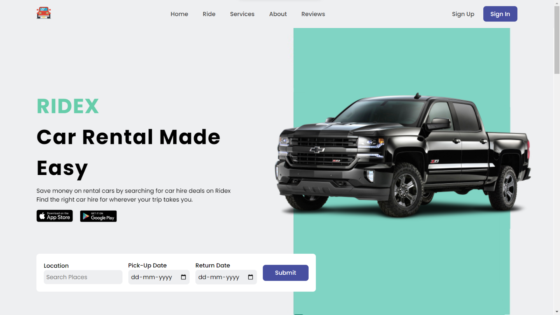

**Description of screenshots:**

First screenshot is the homepage of our website including Location, Pick-Up date and Return date selector .

The second picture includes the steps with which customer will Choose a location, Pick-Up date and Car to be booked.

The third picture shows the available cars with prices on the basis of per day which can be rented out.

Fourth picture includes “About Us” section.

Fifth picture includes the “Customer Reviews” section in which customers can share their reviews and give ratings out of five stars.

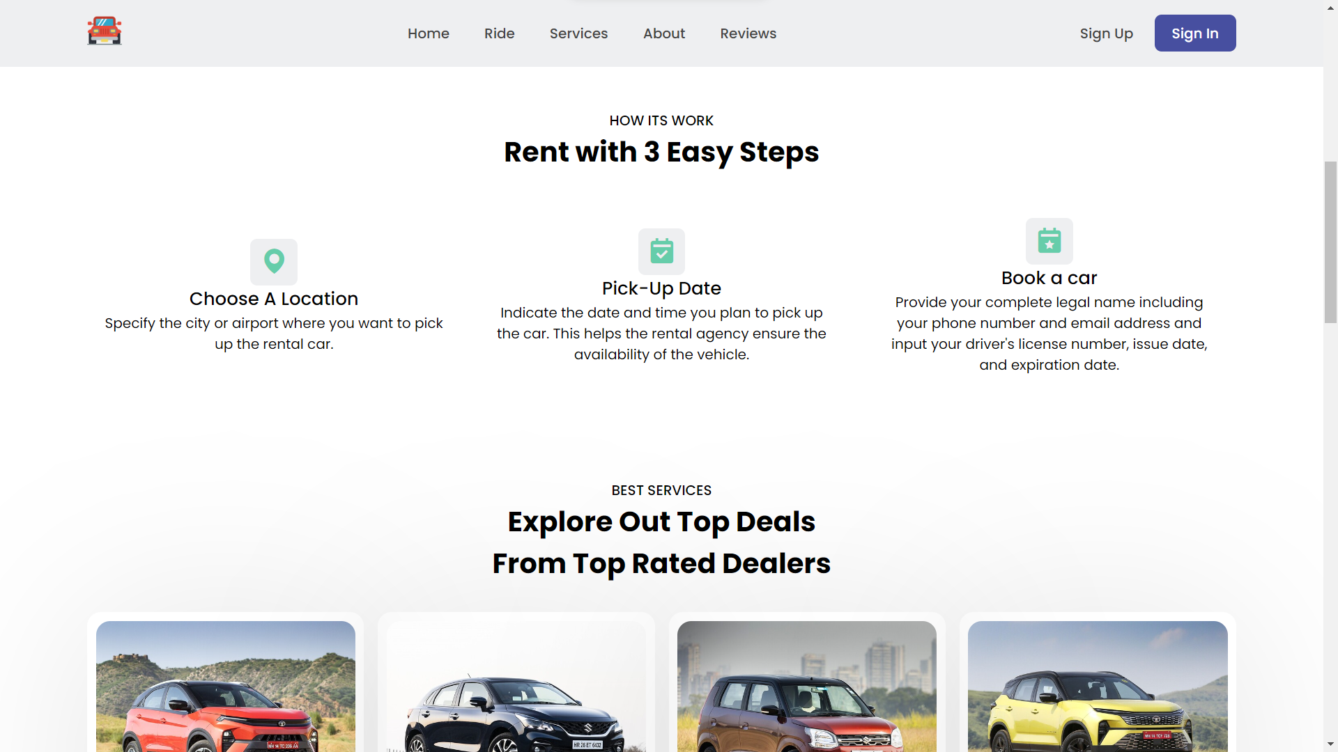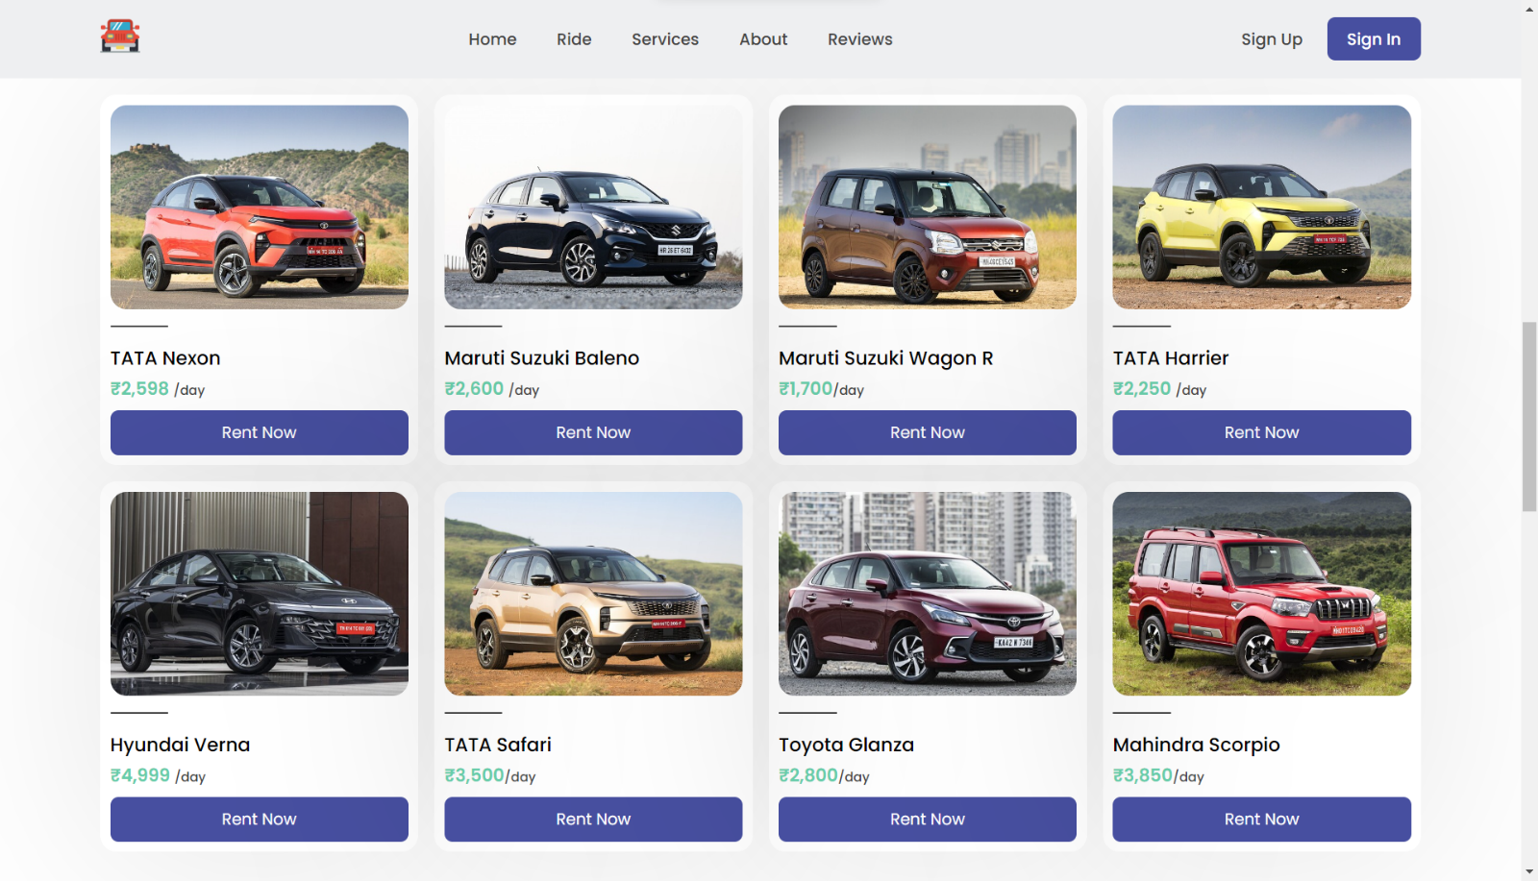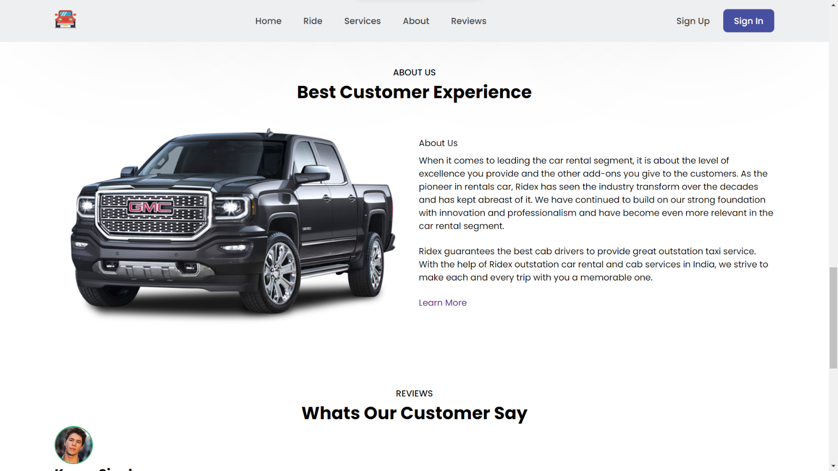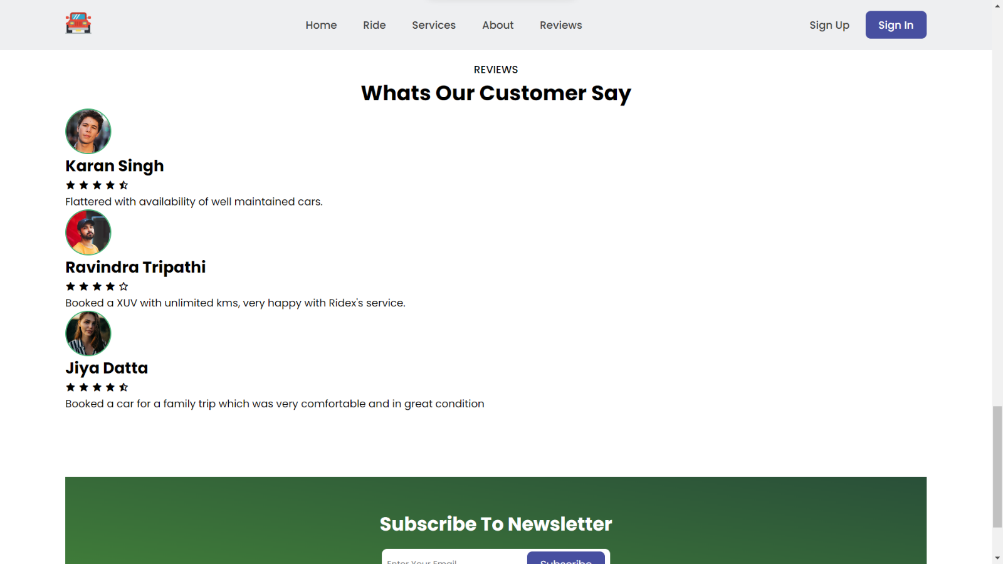

**REFRENCES:**

Icons: https://boxicons.com

Fonts: https://fonts.google.com

Images: <https:///www.carwale.com>, https://pnghunter.com

ScrollReveal: https://scrollrevealjs.org

CSS Colors: https://www.w3schools.com

Photo Editing: https://www.iloveimg.com

<https://www.youtube.com>

**THANK YOU**